Computer Programming I — Homework Assignment #13

Problem: Design a UNI Air Domestic Flights Booking System

Functions:
- Booking (訂票): Insert a new record into the binary file Reservations.dat. Any passenger cannot book twice the same flight on the same day.
- Booking inquiry (訂票紀錄查詢): Input an ID number, then display the reservation information of the passenger.
- Refund application (刪除訂票資料): Delete a record from the binary file Reservations.dat.
Requirements:
1. Global variables, except airportName , fullFare , discount and maxNumReservations, are not allowed.

Remark: The flightNo is unique in each flight.

The file record format of the file Reservations.dat:
char flightNo[ 8 ]; // Flight number
char id[ 12 ]; // ID number
char name[ 8 ]; // Name
char mobile[ 12 ]; // Mobile phone number
char date[ 12 ]; // Departure date
int tickets[ 8 ];
// tickets[ 0 ]: not used
// tickets[ 1 ]: number of full fare tickets
// tickets[ 2 ]: number of child tickets
// tickets[ 3 ]: number of infant tickets
// tickets[ 4 ]: number of senior citizen tickets
// tickets[ 5 ]: number of impaired tickets
// tickets[ 6 ]: number of impaired companion tickets
// tickets[ 7 ]: number of military tickets

The file record format of the file Flight Schedule.dat:
char flightNo[ 8 ]; // Flight number
char aircraft[ 8 ]; // aircraft model
int departureAirport; // Departure airport code
int arrivalAirport; // Arrival airport code
char departureTime[ 8 ]; // Departure time
char arrivalTime[ 8 ]; // Arrival time
int dayWeek[ 7 ]; // the value of dayWeek[ i ] is 0 or 1
// dayWeek[ 0 ] == 1 if and only if the flight flies on Sunday
// dayWeek[ 1 ] == 1 if and only if the flight flies on Monday
// dayWeek[ 2 ] == 1 if and only if the flight flies on Tuesday
// dayWeek[ 3 ] == 1 if and only if the flight flies on Wednesday
// dayWeek[ 4 ] == 1 if and only if the flight flies on Thursday
// dayWeek[ 5 ] == 1 if and only if the flight flies on Friday
// dayWeek[ 6 ] == 1 if and only if the flight flies on Saturday

The file record format of the file Flight Seats.dat:
char date[ 12 ]; // Date
char flightNo[ 8 ]; // Flight number
int departureAirport; // Departure airport code
int arrivalAirport; // Arrival airport code
int availableSeats; // The number of available seats

The screen dialog should appear as follows:
Welcome to UNI Air Domestic Flights Booking System

Input your choice:
1. Booking
2. Booking enquiry
3. Refund application
4. End
? 1

Departure airport:
1. Taipei
2. Taichung
3. Chiayi
4. Tainan
5. Kaohsiung
6. Hualien
7. Taitung
8. Penghu
9. Kinmen
10. Beigan
11. Nangan
? 1

Arrival airport:
6. Hualien
7. Taitung
8. Penghu
9. Kinmen
10. Beigan
11. Nangan
? 8

Departure Date (Month):
1. 2025-12
2. 2026-1
3. 2026-2
4. 2026-3
5. 2026-4
6. 2026-5
? 1

Day (15 ~ 31): 15

Taipei to Penghu / Depart date: 2025/12/15.

Flight Departure Arrival Fare No. Available Seats
8605 08:00 08:50 2296 8
8609 11:30 12:20 2296 8
8615 15:40 16:30 2296 2

Flight number: 8615

Number of infant tickets (0 ~ 2): 0

Number of full fare tickets (0 ~ 2): 3

Number of child tickets (0 ~ 2): 0

Number of senior citizen tickets (0 ~ 2): 0

Number of impaired tickets (0 ~ 2): 0

Number of impaired companion tickets (0 ~ 2): 0

Number of military tickets (0 ~ 2): 0

You can books a maximum of 2 passengers ( including children ).

Number of full fare tickets (0 ~ 2): 0

Number of child tickets (0 ~ 2): 1

Number of senior citizen tickets (0 ~ 2): 0

Number of impaired tickets (0 ~ 2): 0

Number of impaired companion tickets (0 ~ 2): 0

Number of military tickets (0 ~ 2): 0

Ticket information:

Date: 2025/12/15
Flight: B7-8615

Taipei -> Penghu
15:40 16:30

Child Fare TWD 1722 x 1

Total: 1722

ID number: 99

Name: 99

Mobile: 99

Booking completed!

Input your choice:
1. Booking
2. Booking enquiry
3. Refund application
4. End
? 4

Welcome to UNI Air Domestic Flights Booking System

Input your choice:
1. Booking
2. Booking enquiry
3. Refund application
4. End
? 1

Departure airport:
1. Taipei
2. Taichung
3. Chiayi
4. Tainan
5. Kaohsiung
6. Hualien
7. Taitung
8. Penghu
9. Kinmen
10. Beigan
11. Nangan
? 1

Arrival airport:
6. Hualien
7. Taitung
8. Penghu
9. Kinmen
10. Beigan
11. Nangan
? 7

Departure Date (Month):
1. 2025-12
2. 2026-1
3. 2026-2
4. 2026-3
5. 2026-4
6. 2026-5
? 1

Day (15 ~ 31): 15

Taipei to Taitung / Depart date: 2025/12/15.

Flight Departure Arrival Fare No. Available Seats
8721 09:40 10:45 2460 1
8725 13:30 14:35 2460 7
8727 16:50 17:55 2460 4

Flight number: 8727

Number of infant tickets (0 ~ 4): 0

Number of full fare tickets (0 ~ 4): 2

Number of child tickets (0 ~ 4): 0

Number of senior citizen tickets (0 ~ 4): 0

Number of impaired tickets (0 ~ 4): 0

Number of impaired companion tickets (0 ~ 4): 0

Number of military tickets (0 ~ 4): 0

Ticket information:

Date: 2025/12/15
Flight: B7-8727

Taipei -> Taitung
16:50 17:55

Full Fare TWD 2460 x 2

Total: 4920

ID number: 99

Name: 99

Mobile: 99

Booking completed!

Input your choice:
1. Booking
2. Booking enquiry
3. Refund application
4. End
? 1

Departure airport:
1. Taipei
2. Taichung
3. Chiayi
4. Tainan
5. Kaohsiung
6. Hualien
7. Taitung
8. Penghu
9. Kinmen
10. Beigan
11. Nangan
? 1

Arrival airport:
6. Hualien
7. Taitung
8. Penghu
9. Kinmen
10. Beigan
11. Nangan
? 7

Departure Date (Month):
1. 2025-12
2. 2026-1
3. 2026-2
4. 2026-3
5. 2026-4
6. 2026-5
? 1

Day (15 ~ 31): 15

Taipei to Taitung / Depart date: 2025/12/15.

Flight Departure Arrival Fare No. Available Seats
8721 09:40 10:45 2460 1
8725 13:30 14:35 2460 7
8727 16:50 17:55 2460 2

Flight number: 8727

Number of infant tickets (0 ~ 2): 0

Number of full fare tickets (0 ~ 2): 0

Number of child tickets (0 ~ 2): 0

Number of senior citizen tickets (0 ~ 2): 0

Number of impaired tickets (0 ~ 2): 0

Number of impaired companion tickets (0 ~ 2): 0

Number of military tickets (0 ~ 2): 0

Your booking could not be completed!

Input your choice:
1. Booking
2. Booking enquiry
3. Refund application
4. End
? 3

Enter ID number: 99

1. Ticket information:

Date: 2025/12/15
Flight: B7-8615

Taipei -> Penghu
15:00 15:50

Child Fare TWD 1722 x 1

Total: 1722

2. Ticket information:

Date: 2025/12/15
Flight: B7-8727

Taipei -> Taitung
16:50 17:55

Full Fare TWD 2460 x 2

Total: 4920

Enter your choice: 2

The seleted booking has been deleted.

Input your choice:
1. Booking
2. Booking enquiry
3. Refund application
4. End
? 1

Departure airport:
1. Taipei
2. Taichung
3. Chiayi
4. Tainan
5. Kaohsiung
6. Hualien
7. Taitung
8. Penghu
9. Kinmen
10. Beigan
11. Nangan
? 1

Arrival airport:
6. Hualien
7. Taitung
8. Penghu
9. Kinmen
10. Beigan
11. Nangan
? 7

Departure Date (Month):
1. 2025-12
2. 2026-1
3. 2026-2
4. 2026-3
5. 2026-4
6. 2026-5
? 1

Day (15 ~ 31): 15

Taipei to Taitung / Depart date: 2025/12/15.

Flight Departure Arrival Fare No. Available Seats
8721 09:40 10:45 2460 1
8725 13:30 14:35 2460 7
8727 16:50 17:55 2460 4

Flight number: 8727

Number of infant tickets (0 ~ 4): 0

Number of full fare tickets (0 ~ 4): 0

Number of child tickets (0 ~ 4): 0

Number of senior citizen tickets (0 ~ 4): 0

Number of impaired tickets (0 ~ 4): 0

Number of impaired companion tickets (0 ~ 4): 0

Number of military tickets (0 ~ 4): 0

Your booking could not be completed!

Input your choice:
1. Booking
2. Booking enquiry
3. Refund application
4. End
? 4

Call Graph

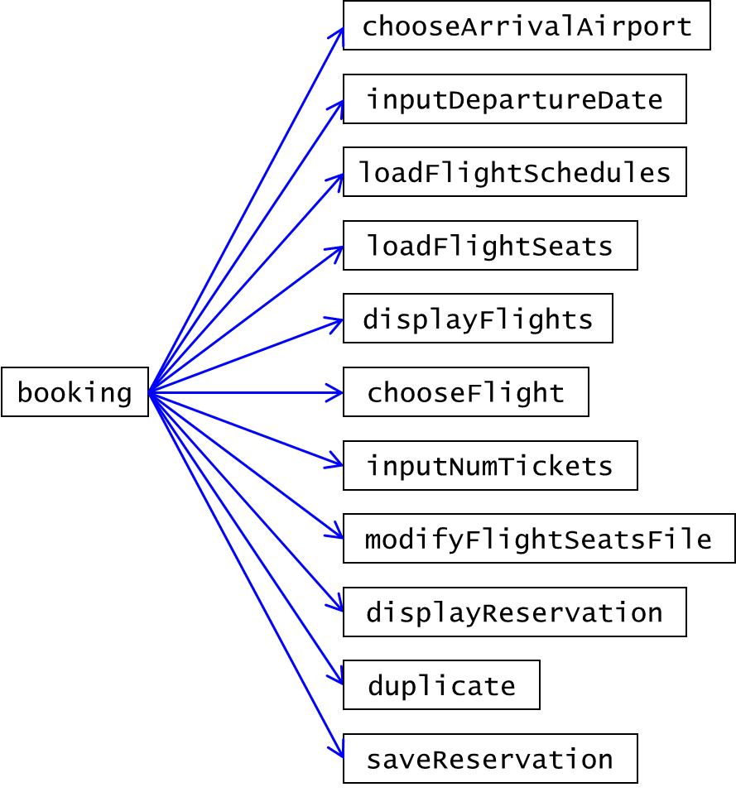

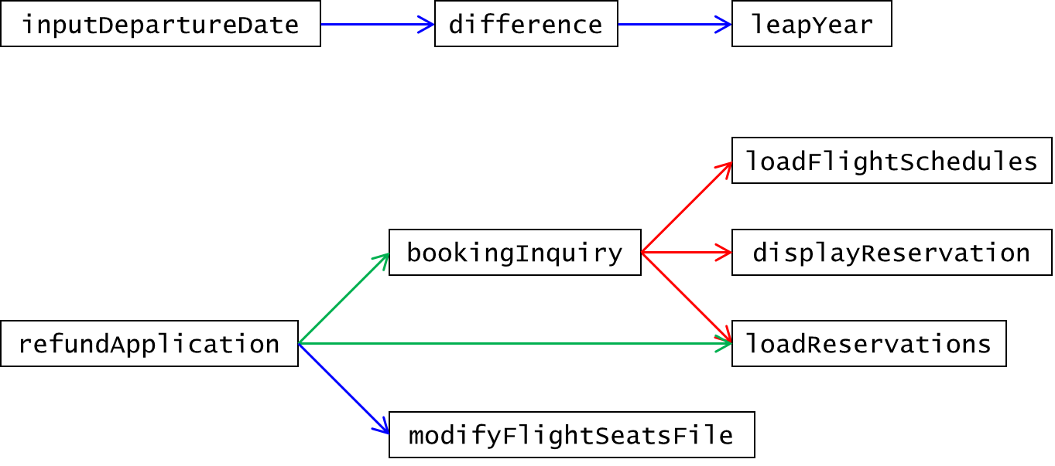

Full Fare
 | Taipei | Taichung | Chiayi | Tainan | Kaohsiung | Hualien | Taitung | Penghu | Kinmen | Beigan | Nangan
Taipei | 0 | 0 | 0 | 0 | 0 | 1781 | 2460 | 2296 | 2618 | 2197 | 2197
Taichung | 0 | 0 | 0 | 0 | 0 | 0 | 0 | 1769 | 2236 | 0 | 2686
Chiayi | 0 | 0 | 0 | 0 | 0 | 0 | 0 | 1721 | 2217 | 0 | 0
Tainan | 0 | 0 | 0 | 0 | 0 | 0 | 0 | 1697 | 2231 | 0 | 0
Kaohsiung | 0 | 0 | 0 | 0 | 0 | 0 | 0 | 1876 | 2393 | 0 | 0
Hualien | 1781 | 0 | 0 | 0 | 0 | 0 | 0 | 0 | 0 | 0 | 0
Taitung | 2460 | 0 | 0 | 0 | 0 | 0 | 0 | 0 | 0 | 0 | 0
Penghu | 2296 | 1769 | 1721 | 1697 | 1876 | 0 | 0 | 0 | 1768 | 0 | 0
Kinmen | 2618 | 2236 | 2217 | 2231 | 2393 | 0 | 0 | 1768 | 0 | 0 | 0
Beigan | 2197 | 0 | 0 | 0 | 0 | 0 | 0 | 0 | 0 | 0 | 0
Nangan | 2197 | 2686 | 0 | 0 | 0 | 0 | 0 | 0 | 0 | 0 | 0

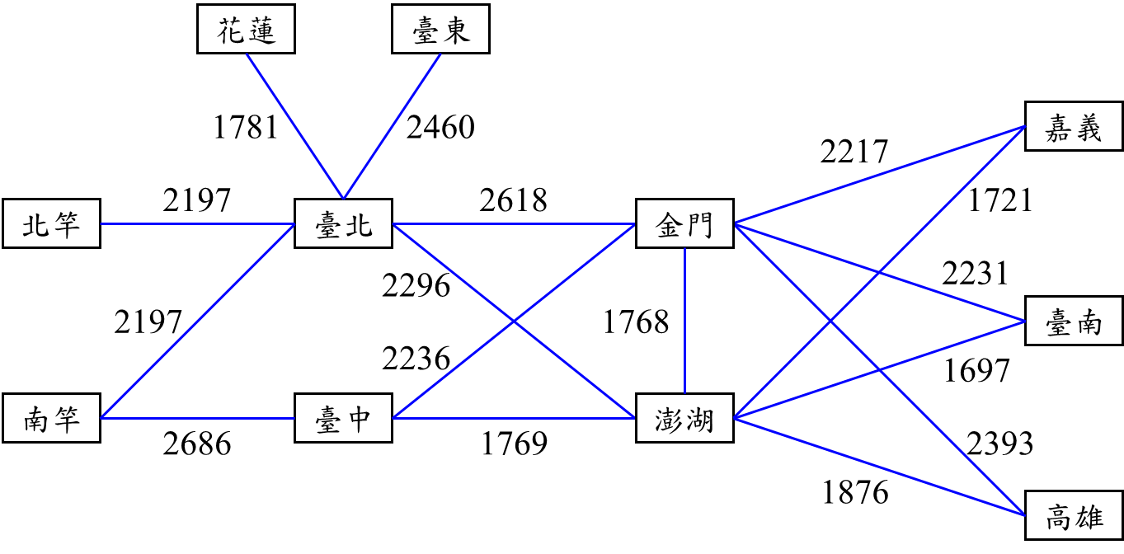

Airport code
Code | Airport | 機場
1 | Taipei | 臺北
2 | Taichung | 臺中
3 | Chiayi | 嘉義
4 | Tainan | 臺南
5 | Kaohsiung | 高雄
6 | Hualien | 花蓮
7 | Taitung | 臺東
8 | Penghu | 澎湖
9 | Kinmen | 金門
10 | Beigan | 北竿
11 | Nangan | 南竿

Flight Schedule.dat

Flight No. | Aircraft | Departure airport | Arrival airport | Departure time | Arrival time | Sun | Mon | Tue | Wed | Thu | Fri | Sat
8971 | AT7 | 1 | 6 | 07:50 | 08:40 | 0 | 0 | 0 | 0 | 1 | 0 | 1
8977 | AT7 | 1 | 6 | 19:00 | 19:50 | 1 | 0 | 0 | 0 | 0 | 1 | 0
8972 | AT7 | 6 | 1 | 09:10 | 09:50 | 0 | 0 | 0 | 0 | 1 | 0 | 1
8978 | AT7 | 6 | 1 | 20:20 | 21:00 | 1 | 0 | 0 | 0 | 0 | 1 | 0
8721 | AT7 | 1 | 7 | 09:40 | 10:45 | 1 | 1 | 1 | 1 | 1 | 1 | 1
8725 | AT7 | 1 | 7 | 13:30 | 14:35 | 1 | 1 | 1 | 1 | 1 | 1 | 1
8727 | AT7 | 1 | 7 | 16:50 | 17:55 | 1 | 1 | 1 | 1 | 1 | 1 | 1
8729 | AT7 | 1 | 7 | 18:45 | 19:50 | 0 | 0 | 0 | 0 | 0 | 1 | 0
8722 | AT7 | 7 | 1 | 11:20 | 12:20 | 1 | 1 | 1 | 1 | 1 | 1 | 1
8726 | AT7 | 7 | 1 | 15:10 | 16:10 | 1 | 1 | 1 | 1 | 1 | 1 | 1
8728 | AT7 | 7 | 1 | 18:40 | 19:40 | 1 | 1 | 1 | 1 | 1 | 1 | 1
8730 | AT7 | 7 | 1 | 20:30 | 21:30 | 0 | 0 | 0 | 0 | 0 | 1 | 0
8605 | A321 | 1 | 8 | 08:00 | 08:50 | 0 | 1 | 1 | 1 | 1 | 1 | 1
9105 | AT7 | 1 | 8 | 09:50 | 10:50 | 1 | 0 | 0 | 0 | 0 | 0 | 0
9105 | AT7 | 1 | 8 | 10:30 | 11:30 | 0 | 0 | 0 | 0 | 1 | 0 | 1
8609 | A321 | 1 | 8 | 11:30 | 12:20 | 1 | 1 | 1 | 1 | 1 | 1 | 1
8615 | A321 | 1 | 8 | 15:00 | 15:50 | 1 | 0 | 0 | 0 | 0 | 0 | 0
8615 | A321 | 1 | 8 | 15:40 | 16:30 | 0 | 1 | 1 | 1 | 1 | 1 | 1
8625 | A321 | 1 | 8 | 18:30 | 19:20 | 1 | 0 | 0 | 0 | 0 | 0 | 0
8606 | A321 | 8 | 1 | 09:50 | 10:40 | 0 | 1 | 1 | 1 | 1 | 1 | 1
8610 | A321 | 8 | 1 | 13:20 | 14:10 | 1 | 1 | 1 | 1 | 1 | 1 | 1
9106 | AT7 | 8 | 1 | 15:40 | 16:35 | 1 | 0 | 0 | 0 | 1 | 0 | 1
8616 | A321 | 8 | 1 | 16:40 | 17:30 | 1 | 0 | 0 | 0 | 0 | 0 | 0
8616 | A321 | 8 | 1 | 17:20 | 18:10 | 0 | 1 | 1 | 1 | 1 | 1 | 1
8626 | A321 | 8 | 1 | 20:10 | 21:00 | 1 | 0 | 0 | 0 | 0 | 0 | 0
8801 | A321 | 1 | 9 | 07:00 | 08:05 | 1 | 1 | 1 | 1 | 1 | 1 | 1
8809 | AT7 | 1 | 9 | 09:00 | 10:20 | 1 | 1 | 0 | 0 | 0 | 1 | 0
9205 | A321 | 1 | 9 | 09:50 | 10:55 | 0 | 0 | 0 | 0 | 0 | 1 | 0
9205 | A321 | 1 | 9 | 10:00 | 11:05 | 0 | 0 | 0 | 0 | 0 | 0 | 1
8811 | A321 | 1 | 9 | 10:45 | 11:50 | 1 | 1 | 1 | 1 | 1 | 1 | 1
8821 | A321 | 1 | 9 | 13:50 | 14:55 | 1 | 1 | 1 | 1 | 1 | 1 | 1
9207 | A321 | 1 | 9 | 15:00 | 16:05 | 0 | 0 | 1 | 0 | 1 | 0 | 0
9207 | A321 | 1 | 9 | 15:40 | 16:45 | 1 | 0 | 0 | 0 | 0 | 0 | 0
8835 | A321 | 1 | 9 | 18:00 | 19:05 | 1 | 1 | 1 | 1 | 1 | 1 | 1
8802 | A321 | 9 | 1 | 08:55 | 09:55 | 1 | 1 | 1 | 1 | 1 | 1 | 1
9206 | A321 | 9 | 1 | 11:50 | 12:50 | 0 | 0 | 0 | 0 | 0 | 1 | 0
9206 | A321 | 9 | 1 | 11:55 | 12:55 | 0 | 0 | 0 | 0 | 0 | 0 | 1
8812 | A321 | 9 | 1 | 12:40 | 13:40 | 1 | 1 | 1 | 1 | 1 | 1 | 1
8816 | AT7 | 9 | 1 | 14:30 | 15:40 | 1 | 1 | 0 | 0 | 0 | 1 | 0
8822 | A321 | 9 | 1 | 15:50 | 16:50 | 1 | 1 | 1 | 1 | 1 | 1 | 1
9208 | A321 | 9 | 1 | 17:00 | 18:00 | 0 | 0 | 1 | 0 | 1 | 0 | 0
9208 | A321 | 9 | 1 | 17:40 | 18:40 | 1 | 0 | 0 | 0 | 0 | 0 | 0
8836 | A321 | 9 | 1 | 20:10 | 21:10 | 1 | 1 | 1 | 1 | 1 | 1 | 1
8781 | AT7 | 1 | 10 | 06:40 | 07:35 | 1 | 1 | 1 | 1 | 1 | 1 | 1
8789 | AT7 | 1 | 10 | 15:20 | 16:15 | 1 | 1 | 1 | 1 | 1 | 1 | 1
8782 | AT7 | 10 | 1 | 08:10 | 09:00 | 1 | 1 | 1 | 1 | 1 | 1 | 1
8790 | AT7 | 10 | 1 | 16:50 | 17:40 | 1 | 1 | 1 | 1 | 1 | 1 | 1
8751 | AT7 | 1 | 11 | 06:30 | 07:25 | 1 | 1 | 1 | 1 | 1 | 1 | 1
8755 | AT7 | 1 | 11 | 09:30 | 10:25 | 1 | 1 | 1 | 1 | 1 | 1 | 1
8775 | AT7 | 1 | 11 | 12:15 | 13:10 | 0 | 1 | 1 | 1 | 1 | 0 | 1
8759 | AT7 | 1 | 11 | 13:05 | 14:00 | 1 | 1 | 1 | 1 | 1 | 1 | 1
8761 | AT7 | 1 | 11 | 14:00 | 14:55 | 1 | 1 | 1 | 1 | 1 | 1 | 1
8767 | AT7 | 1 | 11 | 16:00 | 16:55 | 1 | 1 | 1 | 1 | 1 | 1 | 1
8752 | AT7 | 11 | 1 | 08:00 | 08:50 | 1 | 1 | 1 | 1 | 1 | 1 | 1
8756 | AT7 | 11 | 1 | 11:25 | 12:15 | 1 | 1 | 1 | 1 | 1 | 1 | 1
8758 | AT7 | 11 | 1 | 12:30 | 13:20 | 1 | 1 | 1 | 1 | 1 | 1 | 1
8760 | AT7 | 11 | 1 | 13:45 | 14:35 | 0 | 1 | 1 | 1 | 1 | 0 | 1
8762 | AT7 | 11 | 1 | 14:35 | 15:25 | 1 | 1 | 1 | 1 | 1 | 1 | 1
8768 | AT7 | 11 | 1 | 17:30 | 18:20 | 1 | 1 | 1 | 1 | 1 | 1 | 1
8631 | AT7 | 2 | 8 | 08:30 | 09:15 | 1 | 1 | 1 | 1 | 1 | 1 | 1
8635 | AT7 | 2 | 8 | 11:30 | 12:15 | 1 | 1 | 1 | 1 | 1 | 1 | 1
8639 | A321 | 2 | 8 | 15:10 | 15:50 | 1 | 0 | 0 | 0 | 0 | 0 | 0
8639 | AT7 | 2 | 8 | 15:10 | 15:55 | 0 | 1 | 1 | 1 | 1 | 1 | 1
8651 | AT7 | 2 | 8 | 18:00 | 18:45 | 1 | 1 | 1 | 1 | 1 | 1 | 1
8632 | AT7 | 8 | 2 | 10:00 | 10:40 | 1 | 1 | 1 | 1 | 1 | 1 | 1
8636 | AT7 | 8 | 2 | 13:00 | 13:40 | 1 | 1 | 1 | 1 | 1 | 1 | 1
8640 | AT7 | 8 | 2 | 16:30 | 17:10 | 0 | 1 | 1 | 1 | 1 | 1 | 1
8640 | A321 | 8 | 2 | 16:40 | 17:20 | 1 | 0 | 0 | 0 | 0 | 0 | 0
8652 | AT7 | 8 | 2 | 19:20 | 20:00 | 1 | 1 | 1 | 1 | 1 | 1 | 1
8955 | AT7 | 2 | 9 | 08:00 | 09:05 | 1 | 1 | 1 | 1 | 1 | 0 | 1
8957 | A321 | 2 | 9 | 11:20 | 12:10 | 0 | 0 | 0 | 0 | 0 | 1 | 0
8957 | AT7 | 2 | 9 | 11:20 | 12:25 | 1 | 1 | 1 | 1 | 1 | 0 | 1
8961 | AT7 | 2 | 9 | 14:20 | 15:25 | 1 | 1 | 1 | 1 | 1 | 1 | 1
8965 | AT7 | 2 | 9 | 17:35 | 18:40 | 0 | 1 | 1 | 1 | 1 | 1 | 1
8965 | A321 | 2 | 9 | 18:15 | 19:05 | 1 | 0 | 0 | 0 | 0 | 0 | 0
8956 | AT7 | 9 | 2 | 09:50 | 10:50 | 1 | 1 | 1 | 1 | 1 | 0 | 1
8960 | A321 | 9 | 2 | 13:30 | 14:20 | 0 | 0 | 0 | 0 | 0 | 1 | 0
8960 | AT7 | 9 | 2 | 13:30 | 14:30 | 1 | 1 | 1 | 1 | 1 | 0 | 1
8962 | AT7 | 9 | 2 | 16:00 | 17:00 | 1 | 1 | 1 | 1 | 1 | 1 | 1
8966 | AT7 | 9 | 2 | 19:30 | 20:30 | 0 | 1 | 1 | 1 | 1 | 1 | 1
8966 | A321 | 9 | 2 | 19:55 | 20:45 | 1 | 0 | 0 | 0 | 0 | 0 | 0
8735 | AT7 | 2 | 11 | 10:40 | 11:45 | 1 | 1 | 1 | 1 | 1 | 1 | 1
8736 | AT7 | 11 | 2 | 15:40 | 16:45 | 1 | 1 | 1 | 1 | 1 | 1 | 1
8661 | AT7 | 3 | 8 | 15:40 | 16:10 | 1 | 1 | 1 | 1 | 1 | 1 | 1
8662 | AT7 | 8 | 3 | 14:30 | 15:00 | 1 | 1 | 1 | 1 | 1 | 1 | 1
8901 | AT7 | 3 | 9 | 12:40 | 13:30 | 1 | 1 | 0 | 0 | 0 | 1 | 0
8902 | AT7 | 9 | 3 | 11:00 | 11:55 | 1 | 1 | 0 | 0 | 0 | 1 | 0
8675 | AT7 | 4 | 8 | 07:20 | 07:50 | 1 | 1 | 1 | 1 | 1 | 1 | 1
8681 | AT7 | 4 | 8 | 13:10 | 13:40 | 1 | 1 | 1 | 1 | 1 | 1 | 1
8683 | AT7 | 4 | 8 | 17:10 | 17:40 | 1 | 1 | 1 | 1 | 1 | 1 | 1
8676 | AT7 | 8 | 4 | 08:35 | 09:10 | 1 | 1 | 1 | 1 | 1 | 1 | 1
8680 | AT7 | 8 | 4 | 14:20 | 14:55 | 1 | 1 | 1 | 1 | 1 | 1 | 1
8682 | AT7 | 8 | 4 | 15:50 | 16:25 | 1 | 1 | 1 | 1 | 1 | 1 | 1
8981 | AT7 | 4 | 9 | 09:50 | 10:40 | 1 | 1 | 1 | 1 | 1 | 1 | 1
8991 | AT7 | 4 | 9 | 15:40 | 16:30 | 1 | 1 | 1 | 1 | 1 | 1 | 1
8982 | AT7 | 9 | 4 | 11:30 | 12:25 | 1 | 1 | 1 | 1 | 1 | 1 | 1
8992 | AT7 | 9 | 4 | 17:10 | 18:05 | 1 | 1 | 1 | 1 | 1 | 1 | 1
8689 | AT7 | 5 | 8 | 07:00 | 07:40 | 1 | 1 | 1 | 1 | 1 | 1 | 1
8691 | A321 | 5 | 8 | 08:00 | 08:40 | 0 | 0 | 0 | 0 | 0 | 1 | 1
8695 | AT7 | 5 | 8 | 09:50 | 10:30 | 1 | 1 | 1 | 1 | 1 | 1 | 0
8697 | AT7 | 5 | 8 | 10:50 | 11:30 | 1 | 1 | 1 | 1 | 1 | 1 | 1
8701 | AT7 | 5 | 8 | 13:00 | 13:40 | 1 | 1 | 1 | 1 | 1 | 1 | 1
8707 | AT7 | 5 | 8 | 14:30 | 15:10 | 1 | 1 | 1 | 1 | 1 | 1 | 1
8715 | A321 | 5 | 8 | 18:00 | 18:40 | 1 | 1 | 0 | 0 | 0 | 1 | 0
8715 | AT7 | 5 | 8 | 18:20 | 19:00 | 0 | 0 | 1 | 1 | 1 | 0 | 1
8690 | AT7 | 8 | 5 | 08:20 | 09:00 | 1 | 1 | 1 | 1 | 1 | 1 | 1
8692 | A321 | 8 | 5 | 09:30 | 10:10 | 0 | 0 | 0 | 0 | 0 | 1 | 1
8696 | AT7 | 8 | 5 | 11:10 | 11:50 | 1 | 1 | 1 | 1 | 1 | 1 | 1
8698 | AT7 | 8 | 5 | 12:30 | 13:10 | 1 | 1 | 1 | 1 | 1 | 1 | 1
8710 | AT7 | 8 | 5 | 16:50 | 17:30 | 1 | 1 | 1 | 1 | 1 | 1 | 1
8712 | AT7 | 8 | 5 | 18:30 | 19:10 | 1 | 1 | 1 | 1 | 1 | 1 | 1
8716 | AT7 | 8 | 5 | 19:30 | 20:10 | 0 | 0 | 1 | 1 | 1 | 0 | 1
8716 | A321 | 8 | 5 | 19:30 | 20:10 | 1 | 1 | 0 | 0 | 0 | 1 | 0
8911 | AT7 | 5 | 9 | 07:30 | 08:35 | 1 | 1 | 1 | 1 | 1 | 1 | 1
8917 | A321 | 5 | 9 | 11:10 | 12:00 | 1 | 1 | 1 | 1 | 1 | 1 | 1
8921 | AT7 | 5 | 9 | 14:00 | 15:05 | 1 | 1 | 1 | 1 | 1 | 1 | 0
8927 | A321 | 5 | 9 | 17:30 | 18:20 | 0 | 0 | 0 | 0 | 0 | 0 | 1
8927 | AT7 | 5 | 9 | 17:30 | 18:35 | 1 | 1 | 1 | 1 | 1 | 1 | 0
8912 | AT7 | 9 | 5 | 09:10 | 10:10 | 1 | 1 | 1 | 1 | 1 | 1 | 1
8918 | A321 | 9 | 5 | 13:10 | 14:00 | 1 | 1 | 1 | 1 | 1 | 1 | 1
8922 | AT7 | 9 | 5 | 15:40 | 16:40 | 1 | 1 | 1 | 1 | 1 | 1 | 0
8928 | A321 | 9 | 5 | 19:20 | 20:10 | 0 | 0 | 0 | 0 | 0 | 0 | 1
8928 | AT7 | 9 | 5 | 19:20 | 20:20 | 1 | 1 | 1 | 1 | 1 | 1 | 1
8995 | AT7 | 8 | 9 | 12:40 | 13:20 | 1 | 0 | 0 | 0 | 1 | 0 | 1
8996 | AT7 | 9 | 8 | 14:05 | 14:50 | 1 | 0 | 0 | 0 | 1 | 0 | 1

